

Free Crafts Project

Decorate Straw Hats

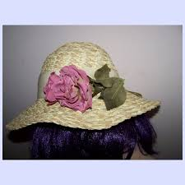

At the Senior Center

9:30 Wednesday, June 12th

25 Tremko Lane

Call 860-487-5122 to sign up

Make for yourself, or someone else.